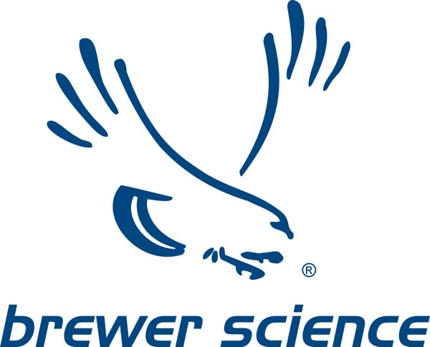

REACH Registration-Only Representative (OR)

Dear Sir/Madam,

The transfer of Brewer Science’s OR entity to the Germany-based Intertek was completed on March 29, 2019. Upon request, letters will be sent to customers with the name and address of the new Intertek OR entity.

With regard to the REACH Classification Labeling and Packaging (CLP) inventory notification, the transfer to the German Brewer Science entity was completed on March 22, 2019. The European Chemicals Agency (ECHA) has noted that any information from existing notifications made by UK manufacturers or importers will remain available under the conditions of the legal notice that ECHA has published along with the CLP inventory. All new CLP inventory notification will be made by the newly appointed EU entity.

With regard to post-BREXIT compliance with UK REACH-type regulations, following BREXIT, Brewer Science, Inc., will monitor the UK-specific REACH- type regulations that come into force, and in coordination with Intertek, will enter into contracts to ensure compliance

Sincerely, Brewer Science

